In this lab, we will go over the transportation model in Excel. For any type of companies that involve in distribution with several plants, distribution centres, and different regions, this model could be in-use. Please open the in-class example file. As you could see, all information highlighted in blue is given. The goal for us is to find out the shipping plan in order to satisfy regional demand, and stay under the capacity. While finding the right plan, we need to minimize the total cost in order to be as profitable as possible.
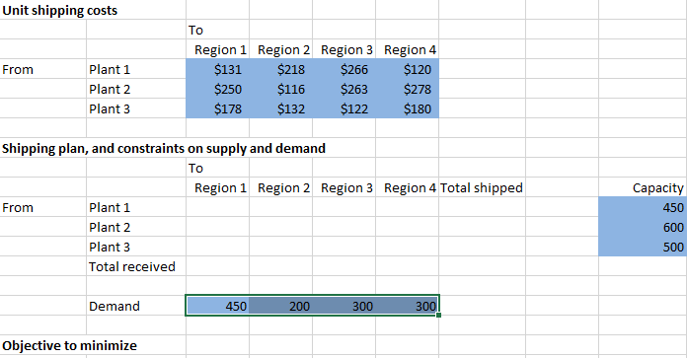
So, applying common logic, the total number of received for each region will need to be bigger than the demand; also the capacity of each plant is set, so the total number of shipped from each plant need to stay under capacity. Let’s present the relationships in this worksheet.
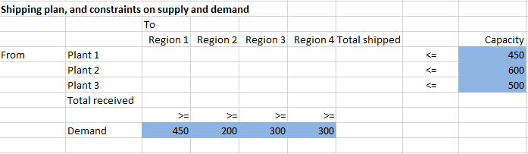
Now, the formula part of this example is easy, all we need is the total number shipped and received, which will be two simple sum functions.
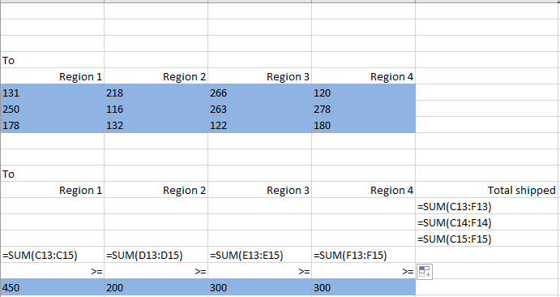
Then, how could we find out the total cost is the last step. The formula we need is “sumproduct”. Sumproduct is a function that act like this. Assuming we have number a, b, and c, each of them has a x, y, and z associate with every single one of them. Sumproduct will allow us to sum ax, by, and cz together easily. In this example, we will just need to put this formula in, make sure every region’s cost is associate with the right shipping quantity cell.
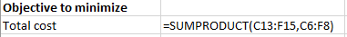
The next step for us to do is ask solver to generate the quantity of shipment at each plant in each region, while satisfy the demand, stay under the capacity, and minimize the total cost.

In-Class Exercise
So, we will use a similar model, in this worksheet, it will ask us to find out a plan that maximize the profit level. For each region, it will have different tax rate, different selling price, and different quantity of demand. Please try this on your own first, then ask tutors’ help afterwards. Hint: separate the cost and selling price, otherwise it’s tricky.
In this exercise, you will use partial absolute reference of cells. The “$” sign means lock. If you want to lock the row, put “$” in front of the number; for column, put “$” sign in front of the letter.
See the partial absolute reference file for details.
Assignment:
Given the information in the worksheet, work out a plan that satisfies all constrains. Each job has to be done on one machine.

