Lab 2 Forecasting Method

Original Sales Data
During this week’s lab, students need to get a hang of forecasting methods that are commonly seen in the business world. They will have access to the whole data set, due to the nature of forecasting is trying to predict the future. The original dataset could be used as a guide, which will be used to calculate the error.
First, open excel file “Ops 255 Lab2.xlsx”. In the first sheet, student could see the original data for Jandal sales in different months.
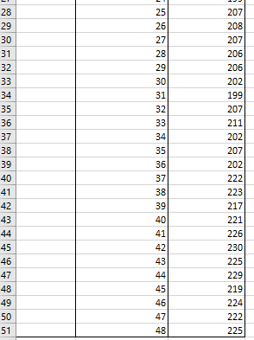
As shown, there are 48 months of data regarding jandal sales. In the following excises, please use different forecasting methods to predict the sales during months 28-48.

Tasks
- Calculate the forecasted sales
- Compare the forecasted sales/actual sales
- Generate error
- Generate linear graph

Methods
- Moving average
- Weighted Moving average
- Linear regression
- Forecast Sheet in Excel

Moving Average Methods

Open the Average Methods sheet, copy and paste the actual sales data (from month 28 to 48) from the Original Data sheet to according cells.
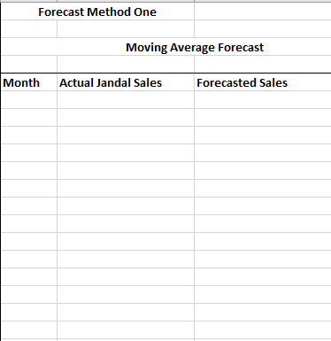
For moving average methods, it requires actual sales data to make forecasting on the future sales. In the formula, remember the calculated average is based on the actual sales data.
- Copy sales data from original data sheet from month 28 to 48
- Paste the copied data in column E
- Use actual Jandal sales data in column F to calculate forecasted sales in column G
- Calculate the differences between the forecasted sales and the actual sales data
- For the sake of analysis, the difference between value should be in absolute format
- Use the calculated error to make linear graph

Weighted Moving Average

Weight moving average is commonly used for businesses that have high fluctuations in their sales, so data from different time periods could have different weight on forecasting the future sales trend.
The Weighted Fraction is given
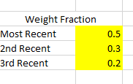
- Copy sales data from original data sheet from month 28 to 48
- Paste the copied data in column E
- Use actual Jandal sales data in column F to calculate forecasted sales in column G
- Calculate the differences between the forecasted sales and the actual sales data
- For the sake of analysis, the difference between value should be in absolute format
- Use the calculated error to make linear graph

Compare the two graphs generated by Excel. (There is some difference between the error graphs, however, they are similar enough to call it close.)
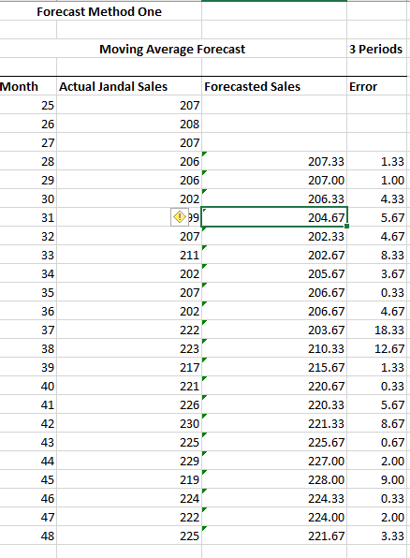

Linear Regression
Use the data set in the separated sheet in linear regression worksheet.
It contains the sales data from month 1 to month 27, use linear regression functions to find out the slope and intercept of the particular linear regression model.
- For any linear regression model, it will have slope and intercept
- Both of them are calculated by using the independent and dependent variables
- Fill in the a: the slope; b: the intercept
- Fill in the linear regression function by using apostrophe before entry.
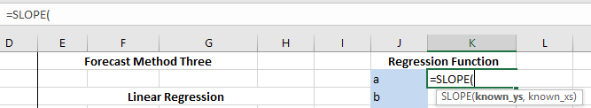
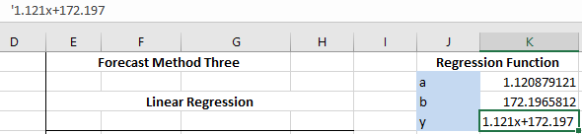
Use the linear regression model to forecast the sales form month 28 to month 48.
- Use the calculated slope and intercept to generate the dependent value-sales
- Use absolute reference functions in Excel to lock on “a” and “b”
- Calculate the error, generate the error graph

Conclusion
There is no right answer when it comes to forecasting methods. All of them are models, which are used by people to show a simplified version of the real world. The lessons to take away from this lab is an introduction to models.
- Models will never be accurate
- Models only work under made-up assumptions
- Models are useful, since there is no way to factor all the variables from real life

Exercise
Generate Linear regression based on the whole data set, then forecast the next 5 months’ jandal sales. Calculate and fill in the answers. (a, b, y)
Use excel based Forecast Sheet to do the forecasting, by using the whole data set.
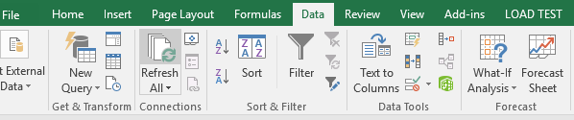
As factored into more variables, also the confident level, it generate a range for forecasted value. It would be more useful than simple methods we’ve used during the tutorial.
Notes: As the technology progress, there will be more tools such as Forecast Sheet to do the work for you. The importance shifts from knowing how to do it, to knowing why to do it. Seeking understanding of the importance of forecasting in organizations, students need to understand the insights instead of only knowing the methods.

