Lab 1-Excel introduction
Please download and open file Excel_introduction from your Canvas.

Copy, Paste, Cut, basic function, formulas (Unassigned Drivers)
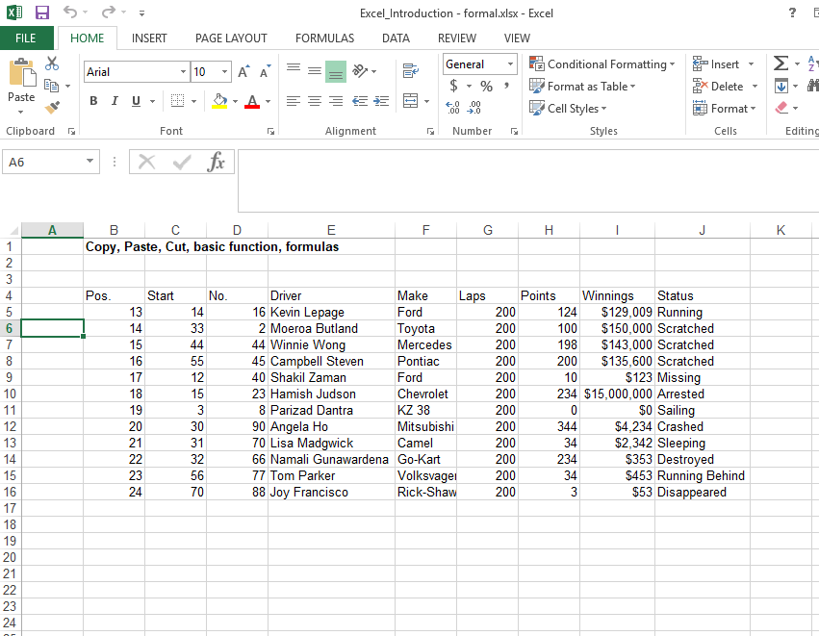
a. Insert rows between 12, 13
b. Copy rows containing Hamish and Parizad, and paste them to row 19, 20.
c. When cutting multiple cells, rows, they need to be next to each other.
d. Type in STAT in F14
e. Use Excel functions and formulas to calculate the Total points, and Average winnings.
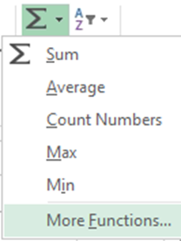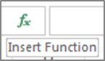
f. Copy paste formulas into H22, and I22. Show, and explain the regularly used paste special: formula, value, and format.
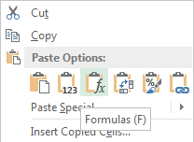

Basic function, formulas, absolute reference, auto fill, fill handle.
Open Worksheet Cal in Excel.
Cells highlighted in yellow-Information given.
Cells highlighted in blue-tasks
- Information in the wrong place (info based on teams like engines; No. driver should be in same fashion)
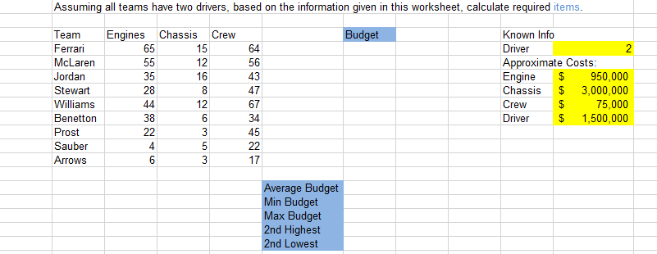
- Add No.Driver next to Crew. Enter value by using autofill handle. Introducing autofill function. It will work on days, weeks, months, and so on.
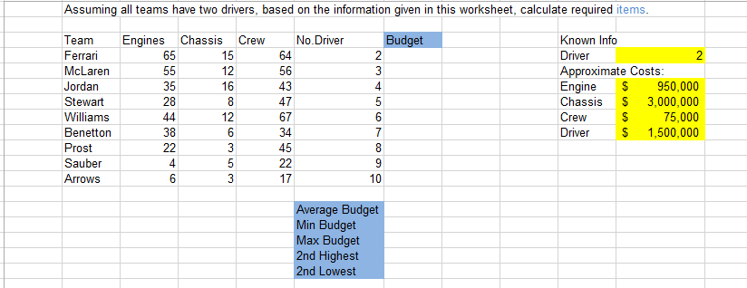

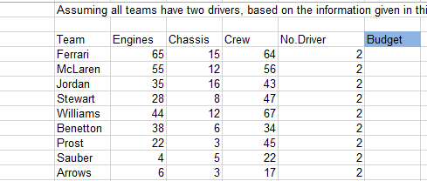

- Calculate the budget for Ferrari

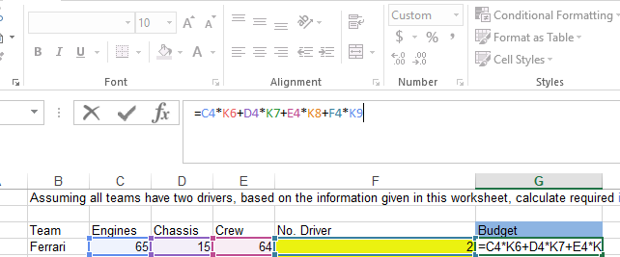

- Use drag handle to calculate budget for other teams
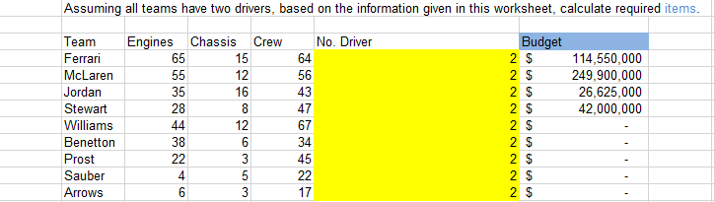

- Introducing absolute reference function, redo the calculation
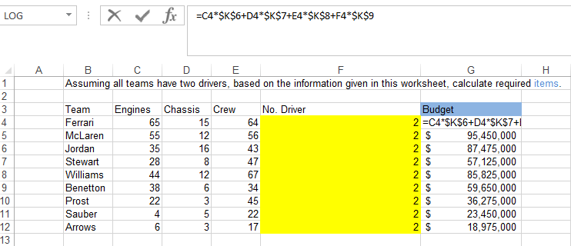
- Reconstruct the function, use fill handle to finish calculation
- Using formula (Average, Min, Max, Large, Small, Countif) to calculate budget stat.
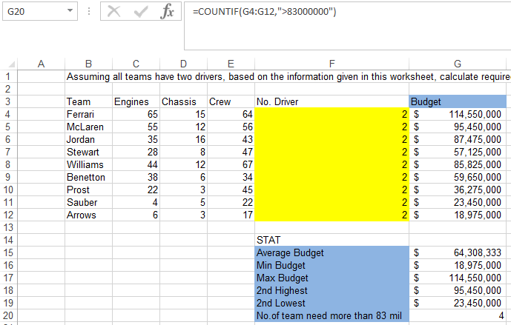

Exercise 1.
Using Assigned driver sheet calculate required items.

Exercise 2.
Read the information, perform tasks accordingly.
Company ABC will merge with company XYZ, however, due to the size difference, XYZ didn’t use any formatted excel file to store data. Now XYZ has asked you to build a formatted excel sheet to store monthly sales data, then construct formulas to allow calculation of total revenue, total cost, and total profit.
The number of sales follow a trend that increase by 250 units each month for 2016, number of sales in Jan 2016 is 25000. The cost for a single item is $15, for each unit sold XYZ will receive $45. Please calculate average profit for each month during 2016.

