Introduction of Solver Add-in
In this lab, you guys will learn the basics of solver. Due to the importance of the add-in, first of all, please start by assuming yourselves as unintelligent, and try your best to pay attention to the lab session.
In this file, all blue high-lightened cells are known information. All the known information is considered as the input to the question. The objective for this excise is to make out the maximum level of profit, given constrains such as demand, and working hours available.
Tech Company PC Experts is looking to assemble PCs using two operation systems. One is basic Windows, the other is Windows XP. The total hours available for assembling PCs are 10000 hours, and the total hours of available for testing is 3000. Based on the historical data, the demand in the market (Maximum sales) is 600 for basic model, 1200 for XP model. Please using these inputs and solver to find out the highest level of total profit for PC Experts.

Please open the excel file: Class.
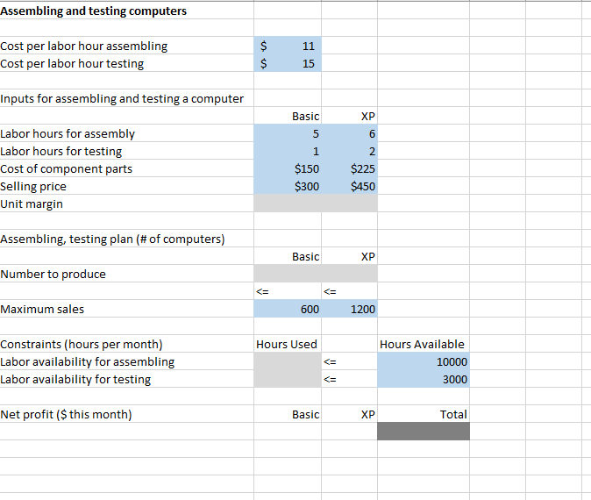
The first step is to recognize the ultimate goal. For this particular example, the goal is to find the max level of net profit for this month. As highlighted in dark grey (D25). Then follow the logic backwards, the first thing we need is to determine how much money every unit could make under given condition. So we need to calculate B12 and C12. In B12, we need to find the total cost and then deduct the total cost from the selling price.
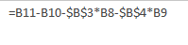
Please type in B12. As you noticed, the absolute references are used in this formula. So, as usual, we will drag the formula to an adjacent cell.
After dragging to C12, the formula in C12 should be:
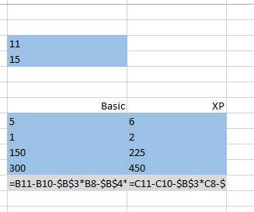
Till this point, the first step for this example is done. The next step is to look at the number to produce and maximum sales. Maximum sales can be considered as demand, which indicates the market size. So, the quantity of production should be smaller than the market demand, since more production means waste. Let’s put “<=” sign above the maximum sales.
Follow the same logic, the total hours available for assembling and testing are limited. So the hours used should be small than the hours available. So we put “<=” in front of hours available.
Next step, we will need to calculate the hours used. Since there are two types of computer and two types works, based on the quantity of production, using the sum product function at B21, and B22 to find out the hours used for assembling and testing separately.
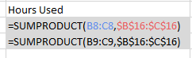
Then the net profit for each type of PC is easy to calculate, simple use the number to produce times the unit margin. Then the sum of these two net profit is the total profit for the whole company.
Remember: Do Not Put actual Numbers In B16, and C16, Solver will do that for us.

Now, we are ready for solver. Your sheet should look like this at this point.
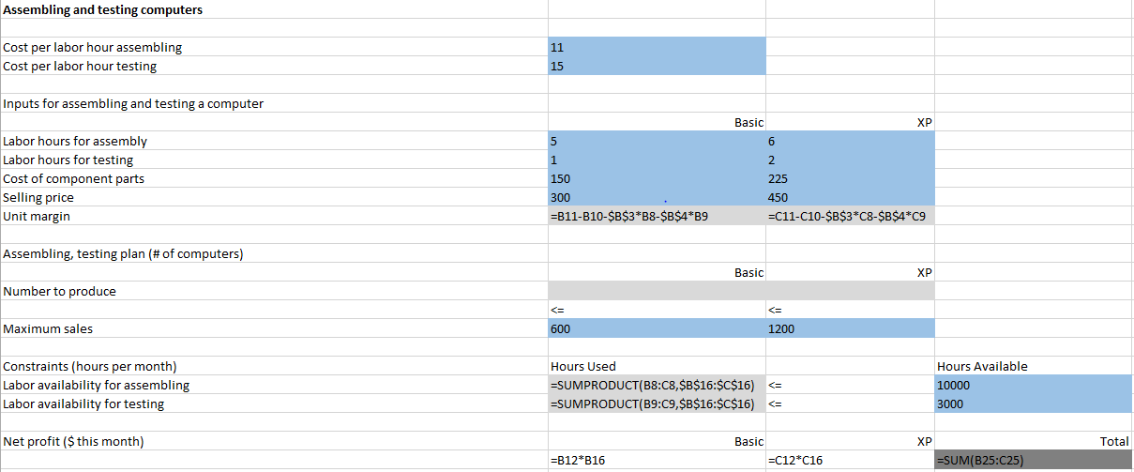
Final step: Solver. Solver is an add-in tool for Excel. It will test different values within the parameters set by you to find the optimal solution based on given condition.
Open solver,
As mentioned, we want to find out the max level of net profit, so put D25 as the objective cell. Tick Max. The changing variable is the values we ask solver to find for us, so the number to produce. The constraints is market demand, and total hours available.

For any linear program, which means the variable has no power to it (X instead of X^2), you should choose Simplex LP, which stands for simple linear program. Also, in this case, the production quantity has to be non-negative, since it won’t make any sense to make negative volume of products.

Your solver should look like this after set-up.
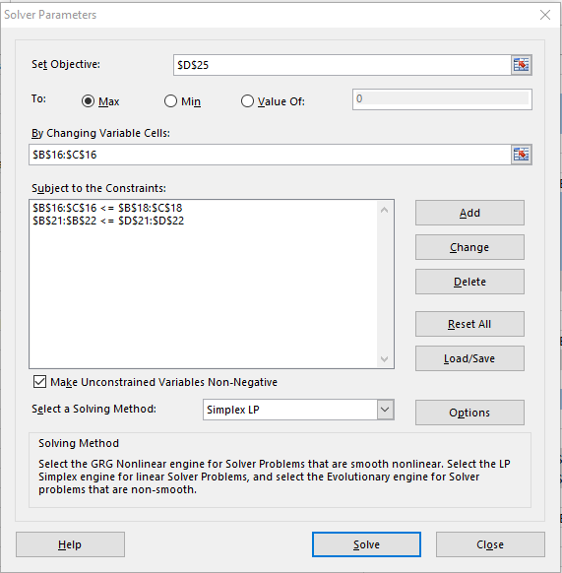

Now click solve-Hope you have the Wua-La moment. Your result should look like this.
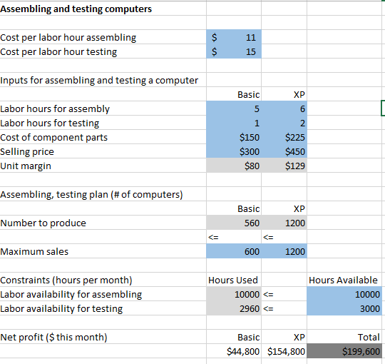

Now, please work on the excise for this lab.

