Example Exercise. Goal Seek
ABC sells hand-knitted sweaters. The company is planning to launch a Facebook ad campaign for its products. The cost of developing the campaign content is $20,000 plus $0.25 per view. The average size of a customer order is $40, and the company’s variable cost per order (due primarily to labor and material costs) averages about $32. The company plans to have 100,000 ad views. It wants to develop a spreadsheet model to answer the following questions:
1. How does a change in the conversion rate, i.e., the share of the ad audience placing an order, affect profit?
2. For what conversion rate does the company break even?
3. If the company estimates a conversion rate of 3%, should it proceed with the campaign?
4. How does the presence of uncertainty affect the usefulness of the model?
Here is the problem we will work through today in the lab. Excel is useful in many circumstances, the key is to formulate problem into a way that Excel could understand, and leave the rest to Excel.
First of all, please open the file: In-class Example. As you could see, given information is highlighted in blue. Before we get into answering all the questions, we need to formulate the question that Excel could understand. We need to find out the formulas for revenue and costs. If any customers respond, their order would be 40$. As a result, the revenue should be number of response*average order. For costs, there is a fixed cost that is independent, which is $20,000, for printing and mailing, it should be number mailed*printing mailing cost. For each order, the variable cost is $32.20, so the total variable order cost should be variable cost per order*number of response.
So, formulate these calculation in Excel, you should have this.
Each cell represents one data point, making sure the all the cells in use is coordinated correctly is the key.
Let’s look at the first question. How does a change in the response rate affect profit?
If you formulate the Excel correctly, with different rate of response you type in, the total profit should change. It is bothersome to type in every data point by hand into a table to show the effect from response rate to profit. So, we will use data table.
Data Table
Starting by type in all the different percentage you want to test in this model in one column. Then use the column next to what you just typed in, and type in “= (your total profit cell)”
Note: your profit cell could be located different than this. It’s okay. The next step is to find data table under what-if analysis tab.
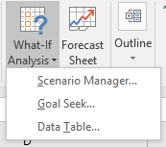
Then highlight the whole data area, not including your table title, then click data table. In the dialogue, let the column input to be your response rate.
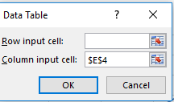
Then press ok. You should have a similar or same table as this, depending on the percentage you want to test.
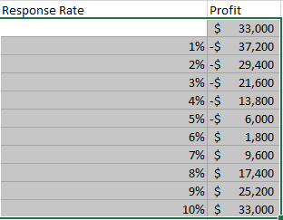
To make things prettier, we will put a graph next to our table. Highlight the whole table, then press recommended chart, pick the scatter graph.
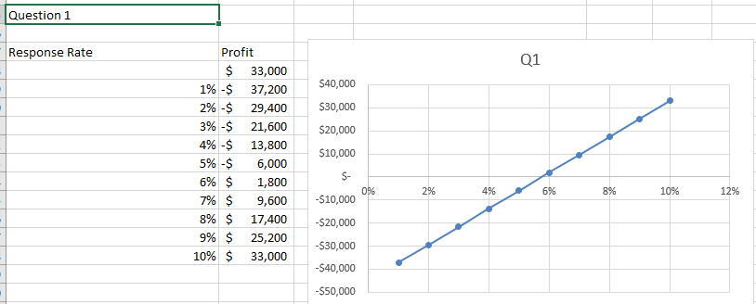
Now we solved the first question.
Question 2
For the second question, the key is to find the break-even point. So we want to find the response rate that will make our firm break even. Break-even means there is no profit, all income could cover all cost, and there is nothing left. We will use Goal-Seek function for this question.
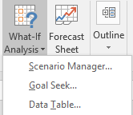 You could find goal-seek under the same tab.
Click goal seek function, set the profit level to 0 by changing response rate.
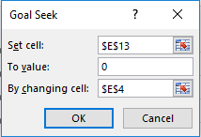
After click ok, you will see 6% in the response rate cell, however, when you select the response rate cell, it will show you the exact percentage before rounding to 6%.
Assignment
Answer the last two questions as your assignment for this lab.

In-class exercise
Now open the file in-class exercise, it’s just a change of number mailed, answer the first two questions again.

