Evolutionary Solver
Today we will go through a special topic together, since this type of problem has been heavily studied in the management science field: The traveling salesperson problem. We will touch the surface, just to plant a seed for you guys, maybe one day you guys could research this classic problem in your further studies.
The problem is easy to understand, a salesperson will have to travel to different places, and how to find the shortest route, or the most efficient way to do his /her work is the main goal for this problem.
In-class example
Minimizing a salesperson’s distance travelled.
Will, who is a salesperson, lives in Boston. He needs to visits each of the cities listed in the dataset. What route should will use to minimize the distance travelled in total?
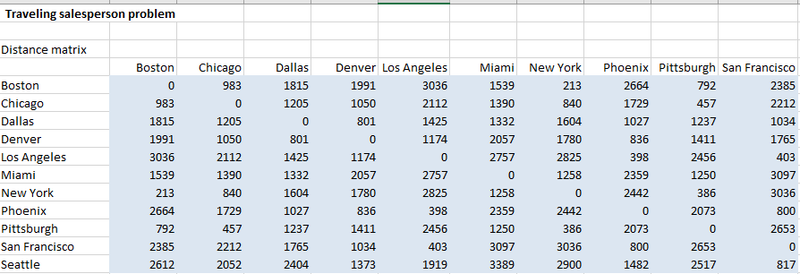
Then we will start solving this problem by assigning different index to the cities. First of all, Will has to travel all the way back to home, since Boston is where he live. We will assign “0” to Boston, then 1 to 10 for the rest 10 cities. You could assign different index, we will use the alphabetical order in this case.
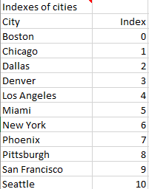
We will use a new formula “Index” in this example. Now, at the route to travel part, type in 0 for Boston, and at the end of the index column. Since his travel starts and ends at Boston. Also, we will ask solver to find the best route, so highlight the cells accordingly.
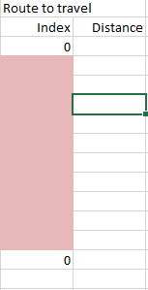
Now, we need to find out the distance travelled. Type in “=index(distance matrix table, D19+1. D20+1)” at E19, then use autofill for the rest distance cells. The “+1” is due to we started by using number “0” for Boston; Excel don’t recognize that. The distance matrix table is the highlighted portion of your worksheet. Do not type in exact words. Also, remember to use absolute reference to the distance matrix table.
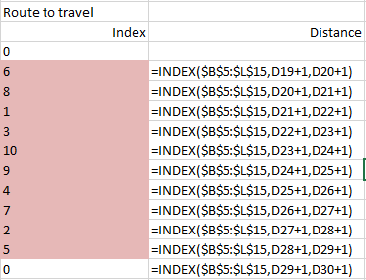
Now, calculate the total distance travelled at according cell. We will move on to solver part.
In this example, we will set up the solver differently. First of all, we need to know the constraints. First constraint, route has to be equal or bigger than 1, since in our index, 0 means home location. Also, the second constraint, it should be smaller or equals to 10, since that is largest number in our index table. Last but not most importantly, all routes should be different. Visiting the same place twice is not efficient. Also, instead of Simplex LP, we will use evolutionary this time. Your solver set-up should look like this.
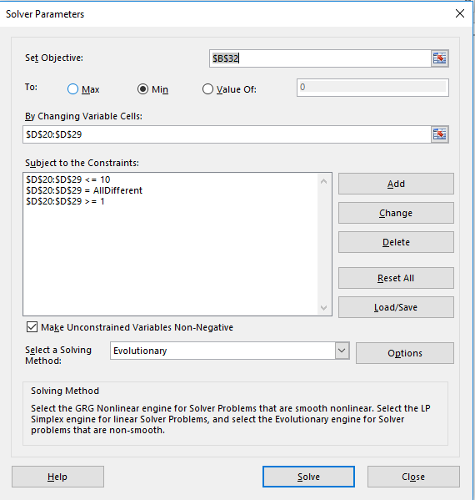
Now click solve, it will take a while, don’t worry. Evolutionary solver will test different scenarios for us, and your result may not be the same to mine, but the total distance travelled should be the same.
Last Lab
Since this is the last lab, we will not have additional in-class exercise, or assignment. I hope these labs are challenged enough to you guys, and hope you guys learned at least some basics about Excel based solver.

