Capacity Planning
In this lab, we will go over the basics of how to use excel to make a capacity planning model. For any particular production facility, finding out the best possible way to plan production is key to success. In this particular example, we are looking to provide a suitable solution for ABC’s capacity planning.
In class example
All cells that are highlighted in blue are the information given.
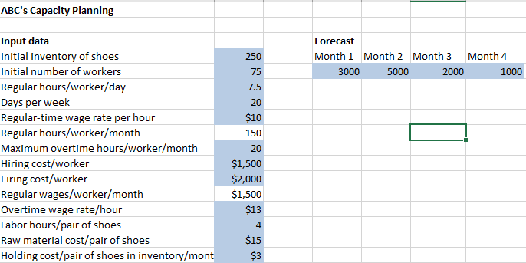
For this type of capacity planning questions, the first step is to identify how many parts are in this question. As we could see, there are inventory, workers, and costs three different parts. So, we will approach this example as such order.
For production/inventory section, we should look to produce enough shoes to meet the demand. Given the already in placed demand forecast, we will need solver to find out the production level for each month for us. Based on the information provided, each pair of shoes will need 4 hours of labour. The hours of labour will come from how many workers we have. So in sequence, we should prioritize the worker plan before production plan. In this example, we need to find out the optimal number of workers that will be hired/fired. So let’s set up the worker plan first. Due to the forecast of the demand is monthly based, so we should format the worker plan in the similar fashion, for simplicity purpose.
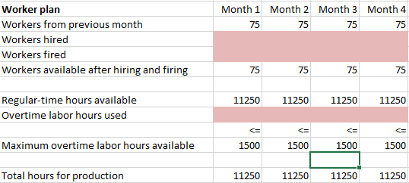
In this part, there are 75 workers initially, we will need to add/deduct the number of workers based on number of workers hired/fired (Highlighted in red). Then the number of workers in the following month would be the same as the ending number of workers for previous month.
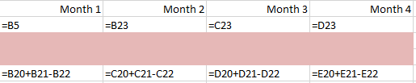
The next step for us is to find out the labour hours available after hire/fire actions each month. From the input we know each worker will bring 150 hours per month. So, the regular hours available should be the number of workers times the regular hours/worker. Also, the number of workers also determined the maximum overtime available for the production facility. The total hours for production is the sum of regular hours, and overtime hours.
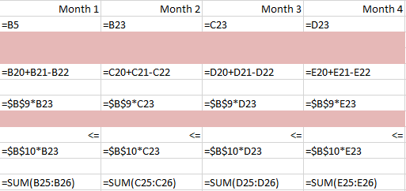

Production Plan
After finishing the worker plan, now we have all labour hours information available to us, so the next step is to work out the production plan. As stated in the input section, the initial inventory is 250. The inventory level for every month should be at least to meet the current demand, also the ending inventory is simply a deduction of forecasted demand from the inventory after production.
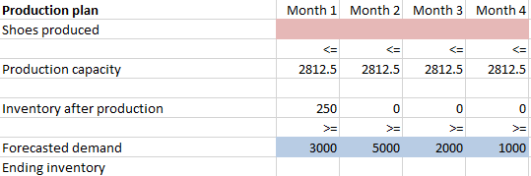
The production capacity could be calculate by: Due to the different level of total hours for production is different each month, the formula should be adapted accordingly.
After the setting up, your file should look like this.
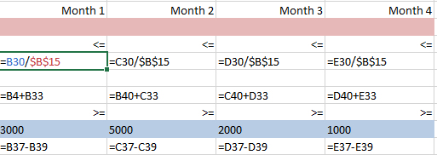
Costs
After the capacity planning, we get to the point with costs. As the guiding force and our goal, the cost is important to be as low as possible. So our objective is to find a plan that generate the lowest total cost, while meeting all the demand, and requirement.
By using information given, working hours, and inventory level, we should be able to find the total cost. If setup correctly, your formulas should look like this.
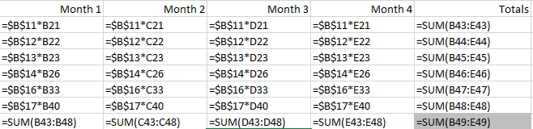
Solver Set-up
In this case, we are looking to find the most economical way to meet the demand, so we will set the objective cell as F49, as it represents the total cost. Following, we will need to hire and fire workers to keep up the production; lastly we need to meet the demand. (Hint. We could only hire and fire whole person, so it should be integer.)
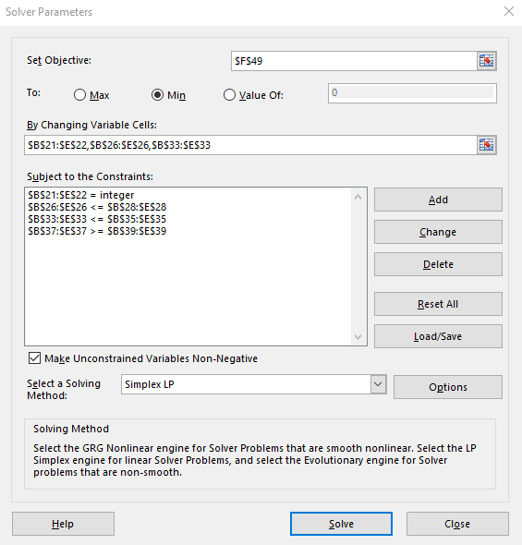
In this case, we will use linear program since the cost is adding up together, it is a linear relationship.
Following, please finish the excise in class, and your assignment on your own. Good luck.
Use InclassExcrise and Assignment file to complete your tasks.

Assignment
A bus company believes that it will need the following numbers of bus drivers during each of the next five years: 60 drivers in year 1; 70 drivers in year 2; 50 drivers in year 3; 65 drivers in year 4; 75 drivers in year 5. At the beginning of each year, the bus company must decide how many drivers to hire or fire. It costs $4000 to hire a driver and $2000 to fire a driver. A driver’s salary is $10,000 per year. At the beginning of year 1, the company has 50 drivers. A driver hired at the beginning of a year can be used to meet the current year’s requirements and is paid full salary for the current year.

