Blending problem
In this lab, we will go through the blending model. Let’s say there is a company called Chandler Oil Blending Company. The goal for it is to get gasoline and heating oil from blending two level of crudes. Each crude has different quality levels. The government has certain set of quality points for gasoline and heating oil to hit.
Open the In-class example document, as usual, all given information is highlighted in blue. The goal for this model is to find the maximum level of revenue, while maintaining the quality points. First thing first, what are the changing variables? At this stage, you should be able to identify it.
Please highlight B16;C17 in any colour other than light blue. These cells are changing variables, since we want to find out how many barrels of crude oil 1 and 2 we are going to use to blend gasoline and heating oil. For each type of crude, there are totally 5000, and 10000 barrels available. Also, one barrel of crude oil is one barrel in quantity, as a result, the barrels sold is the sum of crude oil 1 and 2 used when blending. So, formulate these relationships in.
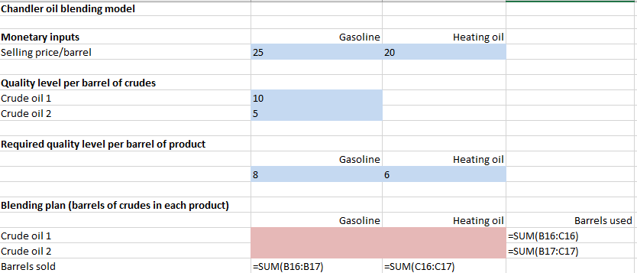

The next step is to make sure the quality points are on point. The required quality level per barrel of each barrel is given, all we need to do is to find out the total quality point based on number of barrels. Simply use formula: =8*barrels sold; we will be able to find the quality points required for gasoline. Do the same for heating oil.
Then, the quality points obtained is based on how many barrels of crude 1 or two are used when blending. By using number of barrels of crude oil 1 times the quality level per barrel, we will find out the quality points obtained. The revenue is simple the selling prices times barrels sold. After these steps, it should look like this.

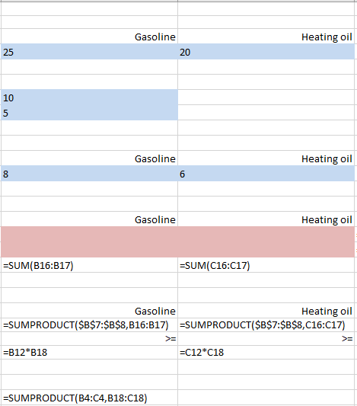
Now, it’s time for solver. As we said, we want to maximize the revenue. So the objective should be the revenue cell. Then put the relationships we identified in. Again, revenue is calculate by a simple linear function (X^1), so we are using simplex LP. Your solver should look similar to this.
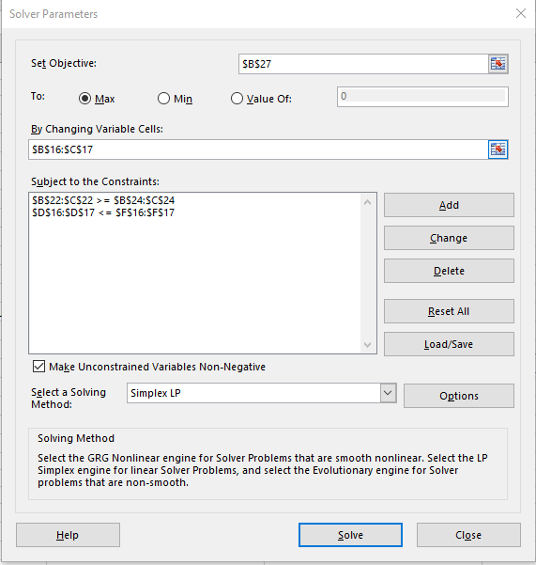
In-class exercise
Please open your in-class exercise file, and finish the in-class exercise. In this situation, the Chandler decided to include one extra quality goal. The percentage of CI include in gasoline and heating oil. Note: you should be able to use the same procedure as the quality goal in your in-class example file. Good luck.

Assignment
In reality, when blending gas or any type of products, there will be certain loss. Now, consider the similar problem, with losses. For blending gasoline, there will be a 5% loss, for heating oil there will be 3% loss. As a result, the yield for one barrel of crude is 0.95, and 0.97 respectively. Use the assignment file to optimize the model.

